Cursus Back-End Developer

Les 7 – Formulieren

**Voorbeeld <form> en <input> (zie bijlage)**

<!DOCTYPE html>

<html>

<head>

<meta charset="utf-8"><title>Formulier</title>

</head>

<body>

<input type="text" name="adres" placeholder="Straatnaam en huisnummer">

</body>

</html>

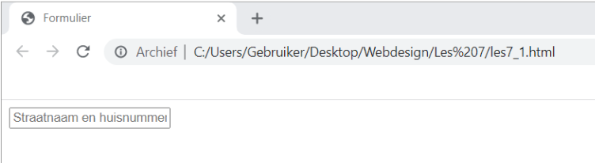

**Verzend button (type, name, value)**

<!DOCTYPE html>

<html>

<head><title>Formulier</title>

</head>

<body><input type="text" name="adres" placeholder="Straatnaam en huisnummer">

<input type="submit" value="Verzend">

</body>

</html>

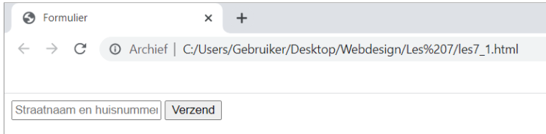

**Button met knopelement (type, name, value)**

<form method="post" action="bewaarInformatie.php">

<input type="text" name="adres" placeholder="Straatnaam en huisnummer">

<button type="submit" name="Verzendknop">

<strong>Verzend</strong></button>

</form>

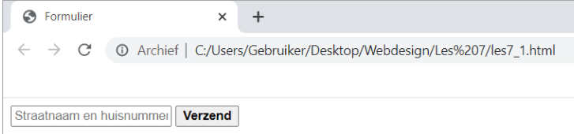

**Wachtwoord (type, name)**

<!DOCTYPE html>

<html>

<head><title>Formulier</title>

</head>

<body><form method="post" action="bewaarInformatie.php">

<input type="text" name="adres" placeholder="Straatnaam en huisnummer">

<input type="password" name="wachtwoord">

<button type="submit" name="Verzendknop">

<strong>Verzend</strong></button>

</form>

</body>

</html>

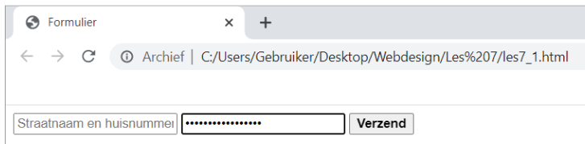

**Cijfers (type, name, value, min, max, step)**

<!DOCTYPE html>

<html>

<head><title>Formulier</title>

</head>

<body><form method="post" action="bewaarInformatie.php">

<input type="text" name="adres" placeholder="Straatnaam en huisnummer">

<p>Uw leeftijd</p>

<input type="number" name="leeftijd" min="1" max="100">

<input type="password" name="wachtwoord">

<button type="submit" name="Verzendknop">

<strong>Verzend</strong></button>

</form>

</body>

</html>

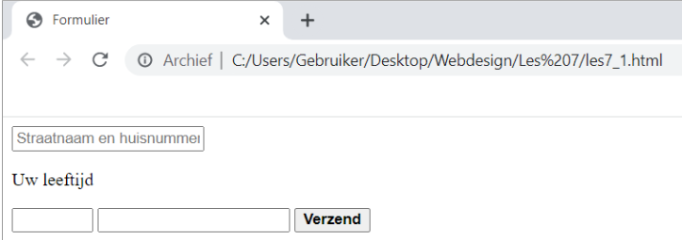

**E-mail, telefoonnummer, URL ( Type, name, value, maxlength, placeholder) In table**

<!DOCTYPE html>

<html>

<head>

<title>Formulier</title>

</head>

<body>

<form method="post" action="bewaarInformatie.php">

<table width="600" border="0">

<tbody>

<tr>

<td width="200"><b>Uw adres</b></td>

<td width="400"><input type="text" name="adres" placeholder="Straatnaam en huisnummer"></td>

</tr>

<tr>

<td><b>Uw leeftijd</b></td>

<td><input type="number" name="leeftijd" min="1" max="100"></td>

</tr>

<tr>

<td><b>Uw wachtwoord</b></td>

<td><input type="password" name="wachtwoord"></td>

</tr>

<tr>

<td><b>Uw e-mailadres</b></td>

<td><input type="email" name="emailadres"></td>

</tr>

<tr>

<td><b>Uw webpagina</b></td>

<td><input type="url" name="webadres"></td>

</tr>

<tr>

<td><b>Uw telefoonnummer</b></td>

<td><input type="tel" name="telefoonnummer"></td>

</tr>

<tr>

<td>&nbsp;</td>

<td><button type="submit" name="verzendknop">

<strong>Verzend</strong></button></td>

</tr>

</tbody>

</table>

</form>

</body>

</html>

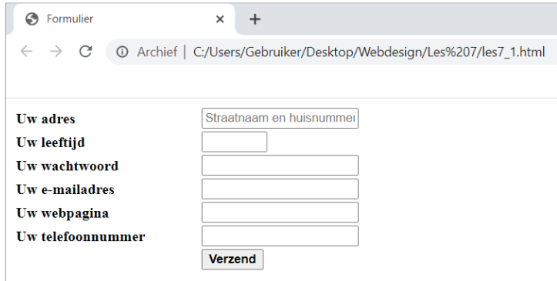

**Datums (type, name, value, min, max, step)**

<!DOCTYPE html>

<html>

<head><title>Formulier</title>

</head>

<body>

<form method="post" action="bewaarInformatie.php">

<table width="600" border="0">

<tbody>

<tr>

<td width="200"><b>Uw adres</b>

</td>

<td width="400">

<input type="text" name="adres" placeholder="Straatnaam en huisnummer">

</td>

</tr>

<tr>

<td><b>Uw leeftijd</b>

</td>

<td><input type="number" name="leeftijd" min="1" max="100">

</td>

</tr>

<tr>

<td><b>Uw wachtwoord</b>

</td>

<td><input type="password" name="wachtwoord">

</td>

</tr>

<tr>

<td><b>Uw e-mailadres</b>

</td>

<td><input type="email" name="emailadres">

</td>

</tr>

<tr>

<td><b>Uw webpagina</b>

</td>

<td><input type="url" name="webadres">

</td>

</tr>

<tr>

<td><b>Uw telefoonnummer</b>

</td>

<td><input type="tel" name="telefoonnummer">

</td>

</tr>

<tr>

<td><b>Uw geboortedatum</b>

</td>

<td><input type="date" name="datum" max="2080-12-31">

</td>

</tr>

<tr>

<td>&nbsp;</td>

<td>

<button type="submit" name="verzendknop">

<strong>Verzend</strong>

</button>

</td>

</tr>

</tbody>

</table>

</form>

</body>

</html>

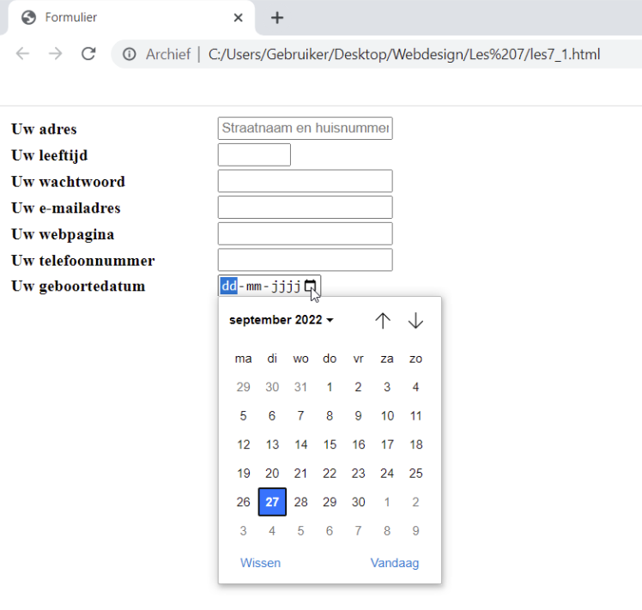

**Zoeken (type, name, maxlength, placeholder)**

input type="search" name="zoek" placeholder="Typ hier uw zoekopdracht">

**Radio Buttons ( type, name, value, checked)**

**Checkboxes (type, name, value, checked)**

<tr>

<td><b>Uw geslacht</b></td>

<td>

<input type="radio" name="geslacht" value="man" checked>Man

<input type="radio" name="geslacht" value="vrouw">Vrouw

<input type="radio" name="geslacht" value="anders">Anders

</td>

<tr>

<tr>

<td><b> Selecteer minimaal een van de aangeboden onderwerpen </b></td>

<td>

<input type="checkbox" name="onderwerpen" value="Sport">Sport

<input type="checkbox" name="onderwerpen" value="Gezondheid">Gezondheid

<input type="checkbox" name="onderwerpen" value="Kunst">Kunst

<input type="checkbox" name="onderwerpen" value="Politiek">Politiek

<input type="checkbox" name="onderwerpen" value="Weer">Weer

</td>

</tr>

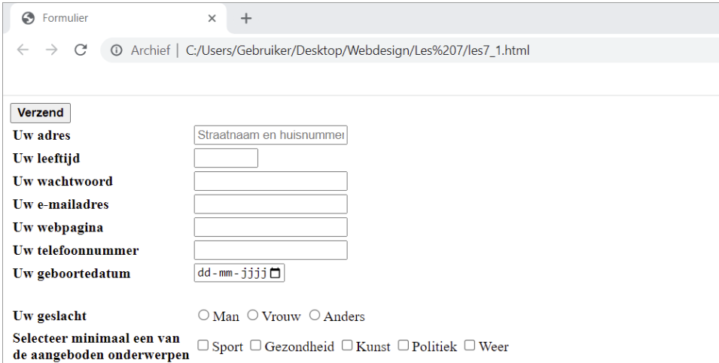

**Bestandsinvoerveld (type, name, accept, multiple)**

<tr>

<td><b>Selecteer uw bestand</b></td>

<td><input type="file" name="document"></td>

</tr>

**Textarea (name, maxlenght, placeholder**)

<textarea name="bericht" maxlength="500"> </textarea>

**Keuzelijst(name, multiple, name, selected)**

<select name="land">

<option value="nl">Nederland</option>

<option value="be" selected>België</option>

<option value="de">Duitsland</option

><option value="fr">Frankrijk</option>

</select>

<tr>

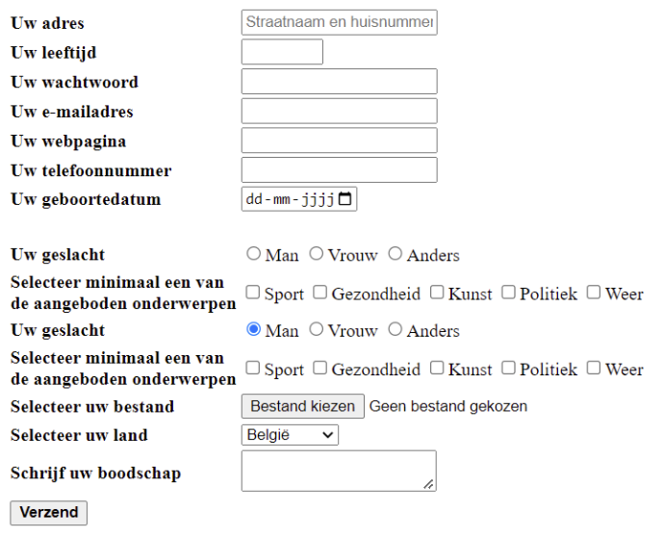<td><b>Selecteer uw bestand</b></td>

<td><input type="file" name="document"></td>

</tr>

<td><b>Selecteer uw land</b></td>

<td><select name="land">

<option value="nl">Nederland</option>

<option value="be" selected>België</option>

<option value="de">Duitsland</option>

<option value="fr">Frankrijk</option>

</select></td>

</tr>

<td><b>Schrijf uw boodschap</b>

</td>

<br>

<td><textarea name ="bericht" maxlength ="1500">

</textarea></td>

</tr>

**Labels (for)**

<label for="naam">Uw naam</label>

<input type="text" id="naam" name="naam">

**Velden groeperen: Fieldset (legend)**

<fieldset>

<legend>Persoonlijke gegevens

</legend>

<label for="naam">Naam:</label>

<input id="naam" type="text" name="naam">

<br>

<br>

<label for="adres">Adres:</label>

<input type="text" id="adres" name="adres">

</fieldset>

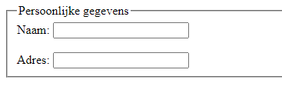

**Mailscript via formspree.io**

<h1>Contactformulier</h1>

<form id="contactform" action="https://formspree.io/f/xbjevyzg" method="post">

<input type="text" name="name" placeholder="Uw naam">

<br>

<br>

<input type="email" name="_replyto" placeholder="Uw email">

<br>

<br>

<input type="hidden" name="_subject" value="Website contact"/>

<textarea name="message" placeholder="Uw bericht">

</textarea>

<br>

<br>

<input type="text" name="_gotcha" style="display:none"/>

<input type="submit" value="Verzend">

<br>

